“How to Be an Inventor”
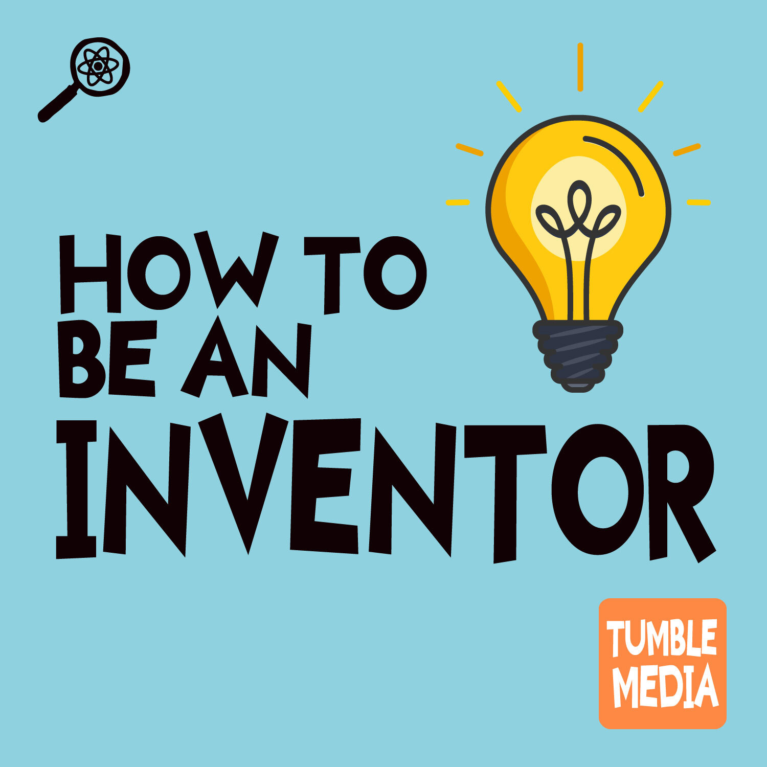
This resource is aligned with the following standards:
Next Generation Science Standards (NGSS)
- 3-5-ETS1-1
- 3-5-ETS1-2
- 3-5-ETS1-3
Common Core Standards
- RI.4.1 – Refer to details and examples in a text when explaining what the text says explicitly and when drawing inferences from the text.
- W.4.7 – Conduct short research projects that build knowledge through investigation of different aspects of a topic.
- SL.4.1 – Engage effectively in a range of collaborative discussions with diverse partners, building on others' ideas and expressing their own clearly.
Table of Contents
Introduction to the Episode 5
How to Use this Packet in Class 6
Lesson Summary 9
Overview 9
Grade Level 9
Standard(s) 9
Time Allotment 10
Learning Objectives 10
Prep for Teachers 10
Before the Lesson 10
Supplies 11
Handouts for Students 11
Invention Design Activity Supplies 11
Media Resources 11
Learning Activities 12
Engage – 10–15 minutes 12
Explore – (time estimate below) 12
Explain – 15–20 minutes 13
Elaborate – 20 minutes 14
Evaluate – 15–20 minutes 14
Interdisciplinary Connections 16
Other Podcast Episodes 16
Other episodes of Tumble about inventors and engineering: 16
Books and Further Reading: 16

Materials Created by
- Associated Universities, Inc.
- OSU STEM Research Center
- Tumble Science Podcast for Kids




- Independence Science

Introduction to the Episode
Welcome to the Tumble Science Podcast for Kids Classroom Resource Packet for "How to Be an Inventor"! This packet is designed to provide upper elementary school teachers with engaging and educational materials aligned with national standards. Through listening and hands-on activities, students will explore the invention process and learn what it takes to turn a problem into a solution that helps real people.
This podcast episode is about Josh Miele, a scientist, inventor, and MacArthur Fellow who is blind. In this episode, Josh walks listeners through the five steps every inventor uses to bring a great idea to life, using his own invention of downloadable tactile maps for blind people as a real-world example. You'll also think like an inventor yourself as you work through your own invention idea!
 Resources:
- Episode Blog Post: Listen to the published episode and find additional links on the blog post for the episode.
- Episode Download: Find the episode with chapter divisions on YouTube.
- Transcript: Download a transcript of the episode
- Teacher Page: Click here to download a page with episode chapter summaries, tiered vocabulary, and an answer key to the listening guide.

How to Use this Packet in Class
There are a number of different ways teachers might integrate podcasts into their classroom routines, and Tumble in particular. How you choose to do this informs how you would use these resources. Here are a couple suggestions for how you might use a podcast in your classroom:
- Listen Actively: Play the episode in “chunks,” using the provided listening guide and encourage students to take notes using the graphic organizers.
- Discussion: Use the guided questions to spark conversations about the concepts explored in the episode.
- Hands-On Activities: Engage students with hands-on experiments that reinforce the episode's themes.
- Cross-Disciplinary Learning: Incorporate literacy, math, and social-emotional learning through connected activities.

Actively Listen to the Episode in Class:
We have heard from multiple teachers who play an episode of Tumble for the whole class as part of a regular lesson, and have the students follow along. Here are two suggestions to help retain student attention while listening to the full episode:
- Use the listening guide included in this resource package to keep students engaged in listening, or design your own resources (graphic organizers, doodling sheets, etc.)
- Break the listening up into chunks of about 2-3 minutes.
This episode has a run time of about 20 minutes. so you’ll want to break it up with lots of discussion. We’ve provided a version of the episode that is already divided into several “chunks” for this purpose.
Assign the episode instead of reading:
This is a great idea for students who struggle with reading. If you want them to learn about the water cycle, instead of having them read an article about it, play this episode! It’s quicker, it’s enjoyable, and it allows students to learn the science content without also having to struggle with reading. Assign the students to listen to this episode, share it on your class site, and assign both a pre-listening activity (ideally done during the school day), and a post-listening activity (done either the next day or at home). If you give multiple options for homework assignments, listening to a podcast is a great option.

Listen to the Episode Over Several Lessons:
You can break up listening to this episode into several short sessions, assigning each section, over the course of a week or two weeks. This could be done in conjunction with some of the activities we’ve included in this resource package.
Play the episode in the background while students are doing other activities: Podcasts can be a great companion to classroom cleanup, art activities, transitions, and so on. Podcasting is ideal for activities where the hands are busy but the language centers of the brain are not - leaving kids free to listen and engage. If you do this, you may wish to reinforce some of the concepts discussed in the episode with a pre- and post- listening activity.

How to Be an Inventor | Lesson Plan

Lesson Summary

Overview
In this lesson, students will listen to an episode of Tumble Science Podcast for Kids and use it as a jumping-off point for learning more about the invention process. After learning how Josh Miele — a blind scientist and inventor — developed tactile maps for blind people, students will apply the five-step invention process to design their own invention ideas. Students will practice identifying problems, conducting research, exploring solutions, prototyping, and thinking about how inventions reach the people who need them.

Grade Level
3 – 5

Standard(s)
NGSS –
3-5-ETS1-1
Define a simple design problem reflecting a need or a want that includes specified criteria for success and constraints on materials, time, or cost.
3-5-ETS1-2
Generate and compare multiple possible solutions to a problem based on how well each is likely to meet the criteria and constraints of the problem.
3-5-ETS1-3
Generate and compare multiple possible solutions to a problem based on how well each is likely to meet the criteria and constraints of the problem.
Common Core / Literacy:
RI.4.1 | Refer to details and examples in a text when explaining what the text says explicitly and when drawing inferences from the text.
W.4.7 | Conduct short research projects that build knowledge through investigation of different aspects of a topic.
SL.4.1 | Engage effectively in a range of collaborative discussions with diverse partners, building on others' ideas and expressing their own clearly.

Time Allotment
These lessons can be performed over two to three days in a classroom.

Learning Objectives
- Students will be able to list and describe the five steps of the invention process as described by inventor Josh Miele.
- Students will be able to identify a real problem and apply the invention process to generate a possible solution.
- Students will explain why it is important to involve potential users in the design process, and describe at least one way they incorporated user perspective into their own invention idea.

Prep for Teachers

Before the Lesson
- Make sure students have the ability to listen to podcast excerpts via the YouTube video.
- Print out lesson handouts (listening guide, graphic organizers, invention planner).
- For the invention design activity:
- Gather basic prototyping materials: paper, cardboard, tape, markers, craft supplies.
- Optional: prepare sticky notes for group brainstorming (Step 3: Explore Options).

Supplies
- Computer or tablet access

Handouts for Students
- Podcast Listening Resources
- Listening Comprehension Questions
- Discussion Questions
- Graphic Organizers & Sketchnotes
- Transcript (also available on the Tumble blog)
- Invention Planner (one per student or per group)
- Five-Step Invention Process Reference Card

Invention Design Activity Supplies
- Paper, cardboard, and basic craft supplies for prototyping
- Sticky notes (for brainstorming options in Step 3)
- Markers and pencils
- Optional: timer for timed brainstorm rounds

Media Resources
- "How to Be an Inventor" (Tumble Science Podcast for Kids)
- Full episode on YouTube (with chapters)
- Episode outline with chapter summaries
- Tumble Blog Post on Episode: https://www.sciencepodcastforkids.com/single-post/how-to-be-an-inventor
- YouTube Chapters for easy excerpt navigation:
- 00:00 – Introduction: Meet Josh Miele
- 03:20 – Step 1: Identify a Problem
- 06:02 – Step 2: Understand the Problem
- 09:59 – Step 3: Explore Options
- 13:53 – Step 4: Experiment!
- 16:44 – Step 5: Get People to Use It
- 19:31 – Closing Activity & Credits

Learning Activities

Engage – 10–15 minutes
- Listen to the Introduction chapter of "How to Be an Inventor" (00:00 – 03:20)
- Facilitate a discussion:
- What do students already know about inventors and inventions?
- Have they ever tried to solve a problem by making or designing something?
- What do they notice about Josh Miele — who he is, what he does, and what makes him a good inventor?
- Writing / Discussion Activity:
- Have students write down their first impressions: What problem does Josh care most about solving, and why?
- Ask students: Do you think you need to have a disability to invent something useful for people with disabilities? Why or why not?
- Using a K-W-L chart, have students record what they already know about inventors and inventions and what they want to learn.

Explore – (time estimate below)
- Listen to the next three episode chapters (Steps 1, 2, and 3 – 03:20 to 13:53)
- Step 1: Identify a Problem – 03:20
- Step 2: Understand the Problem – 06:02
- Step 3: Explore Options – 09:59
- After listening to each chapter, pause and discuss with students:
- What problem did Josh identify? How did he know it was a real problem worth solving?
- Why did Josh need to talk to other blind people before designing a solution? What did he learn?
- What were Josh's options for solving the map problem? Why did he choose tactile maps?
- Conduct the following invention design activity (1 hr or more, depending):
- Invention Planner Activity: Students work individually or in small groups to apply Steps 1–3 to their own invention idea.
- Using the Invention Planner handout, students identify a problem they want to solve (Step 1), describe who has this problem and how they know (Step 2), and brainstorm at least two different ways they could solve it (Step 3).
- Encourage students to think about whether they could talk to someone who has the problem they're working on — a family member, classmate, or teacher.
- Groups share their top problem and solution ideas with the class. Class discusses pros and cons of different approaches.
- Draw connections to Josh's work:
- How did the way you identified a problem compare to how Josh identified his?
- What did you learn from thinking about who has the problem and what they actually need?

Explain – 15–20 minutes
- Listen to Steps 4 and 5 (13:53 – 19:31)
- Step 4: Experiment! – 13:53
- Step 5: Get People to Use It – 16:44
- Discuss with students:
- What is a prototype? Why is it important to build one before your invention is finished?
- What is a "smoke test"? What happened when Josh ran his?
- Why isn't an invention finished when it works? What still has to happen?
- Connect to the Invention Planner activity:
- Have students add to their planners: What would their prototype look like? How would they get people to use their invention once it's built?
- Discuss the relevant concepts as a class: What did we learn about the full invention process? How does each step depend on the one before it?

Elaborate – 20 minutes
- Discuss with students: Josh said that anybody could have invented tactile maps before he did — but they didn't, because they didn't know it was needed. What does that tell us about who should be involved in inventing things?
- Extension activity: Have students revise their Invention Planner based on what they learned in the Explain phase. Is their solution still the best one? Do they want to change anything now that they've thought about prototyping and distribution?
- Optional: Have students create a simple physical prototype of their invention using available classroom materials. Groups present their prototypes and explain how they addressed the five invention steps.

Evaluate – 15–20 minutes
- Listen to the Closing Activity chapter (19:31)
- Class discussion, reflecting on the episode and the activity:
- What are the five steps of the invention process? Can you explain each one in your own words?
- Which step do you think is the most important, and why?
- Were there predictions or ideas you had at the start of class that changed after listening to Josh and doing the activity?
- If you were going to keep working on your invention, what would your next step be?
- Assessment options:
- Completed Invention Planner (all five steps filled in with reasoning)
- Written reflection: Which of Josh's five steps was hardest for you to think through? What would you do differently next time?
- Group presentation of invention idea, addressing all five steps

Interdisciplinary Connections

Other Podcast Episodes
- "How Do Airplanes Fly?" – Brains On! — How did humans figure out flight wasn't as simple as strapping on wings? Co-hosts share the frustrations and joys of being inventors themselves as they explore the history and science of flight. Interdisciplinary connections: engineering design, physics, history of invention.
- "Meet Gitanjali Rao, Time Magazine's First-Ever Kid of the Year" – Brains On! — Molly and teen inventor Gitanjali Rao discuss how kids can turn ideas into reality and why young people's viewpoints matter in solving real-world problems. Interdisciplinary connections: engineering design, social justice, STEM advocacy.

Other episodes of Tumble about inventors and engineering:
- Reinventing the Wheel — Engineer Rory Cooper revolutionized the wheelchair, exploring the invention process from its ancient origins to the future of rideable robots.
- How to Build a Robotic Eel — Meet Envirobot, a bio-inspired swimming robot built to detect water pollution, and learn what it takes to turn an animal into a robot.

Books and Further Reading:
- Rosie Revere, Engineer by Andrea Beaty — A picture book about a girl inventor who learns that failure is part of the invention process. A great read-aloud companion for grades 3–5.
- A Young Innovator's Guide to STEM by Gitanjali Rao — Gitanjali Rao's own book for kids on how to turn ideas into inventions, with real-world examples and a step-by-step process that mirrors Josh Miele's five steps.
- Connecting Dots – A Blind Life by Josh Miele — Josh's memoir about growing up blind, becoming a scientist, and inventing technology to make the world more accessible. Recommended for grown-ups and older readers.

