“The Science of Ocean Sounds”

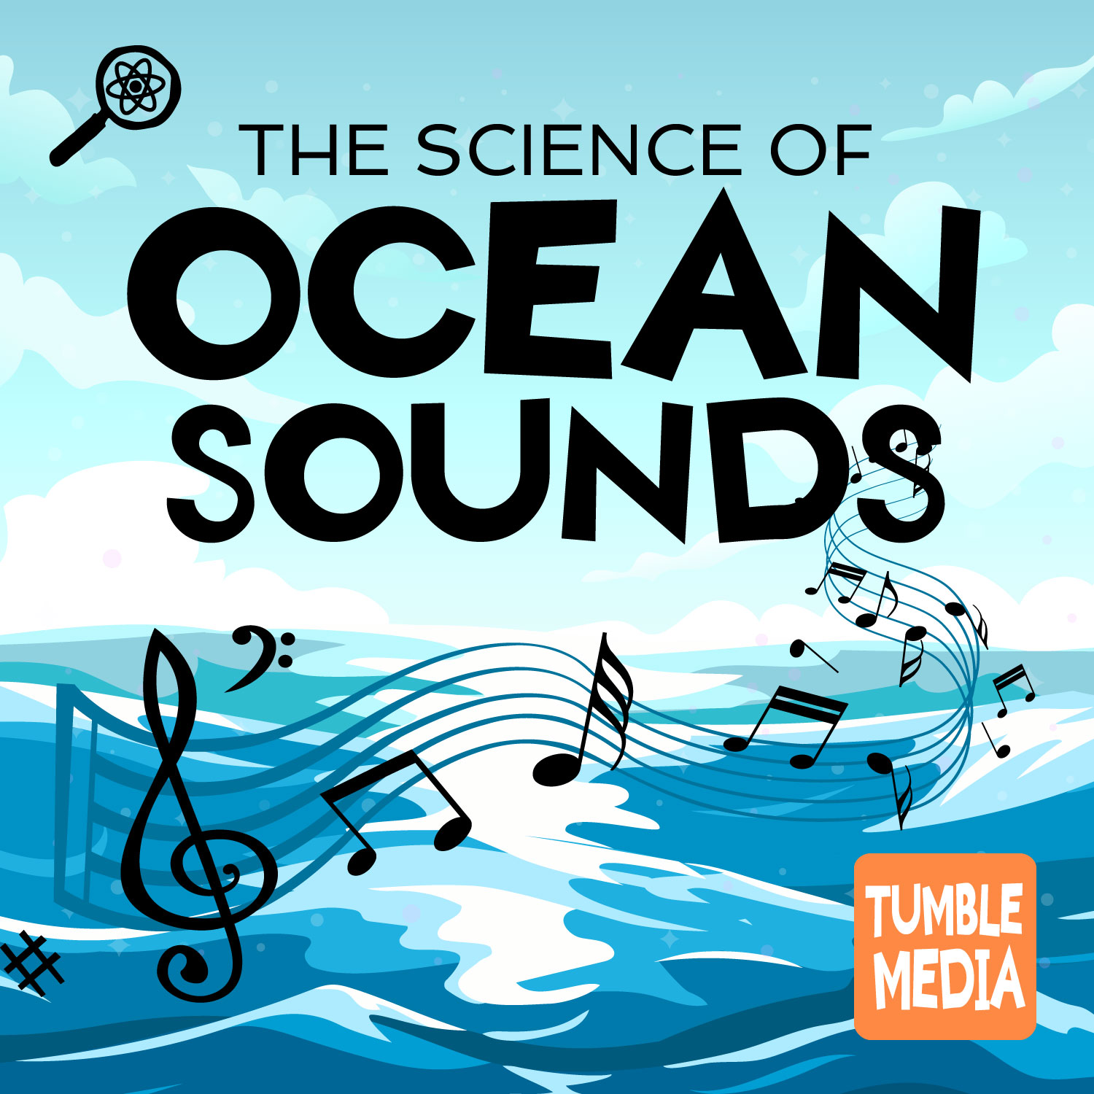  
This resource is aligned with the following standards:

**Next Generation Science Standards (NGSS)**

* ESS2.B: Plate Tectonics and Large-Scale System Interactions
* Crosscutting Concepts: Patterns, Scale, and System Models

**Common Core Standards**

* ELA/Literacy RI.4.7: Interpret information presented in various formats.
* ELA/Literacy W.4.7: Conduct short research projects that build knowledge.

Table of Contents

Introduction to the Episode 3

How to Use this Packet in Class 4

NGSS and Common Core Connections 7

Lesson Plan 9

Learning Activities: 12

Engage ( 10 - 15 minutes) 12

Explore - (time estimates below) 13

Explain - 15-20 minutes 17

Elaborate (20 minutes) 17

Evaluate (15-20 minutes) 18

The Science of Ocean Sounds - Listening Guide 19

PART 1: Before Listening to the Podcast 19

PART 2: Sound Scavenger Hunt 21

PART 3: Checking for Understanding 23

Interdisciplinary Connections & Additional Resources 26

[Full Transcript:  
“The Science of Ocean Sounds” 27](#_heading=h.gy2c939xr2uy)

Materials Created by

* Associated Universities, Inc.
* OSU STEM Research Center
* Tumble Science Podcast for Kids
* Independence Science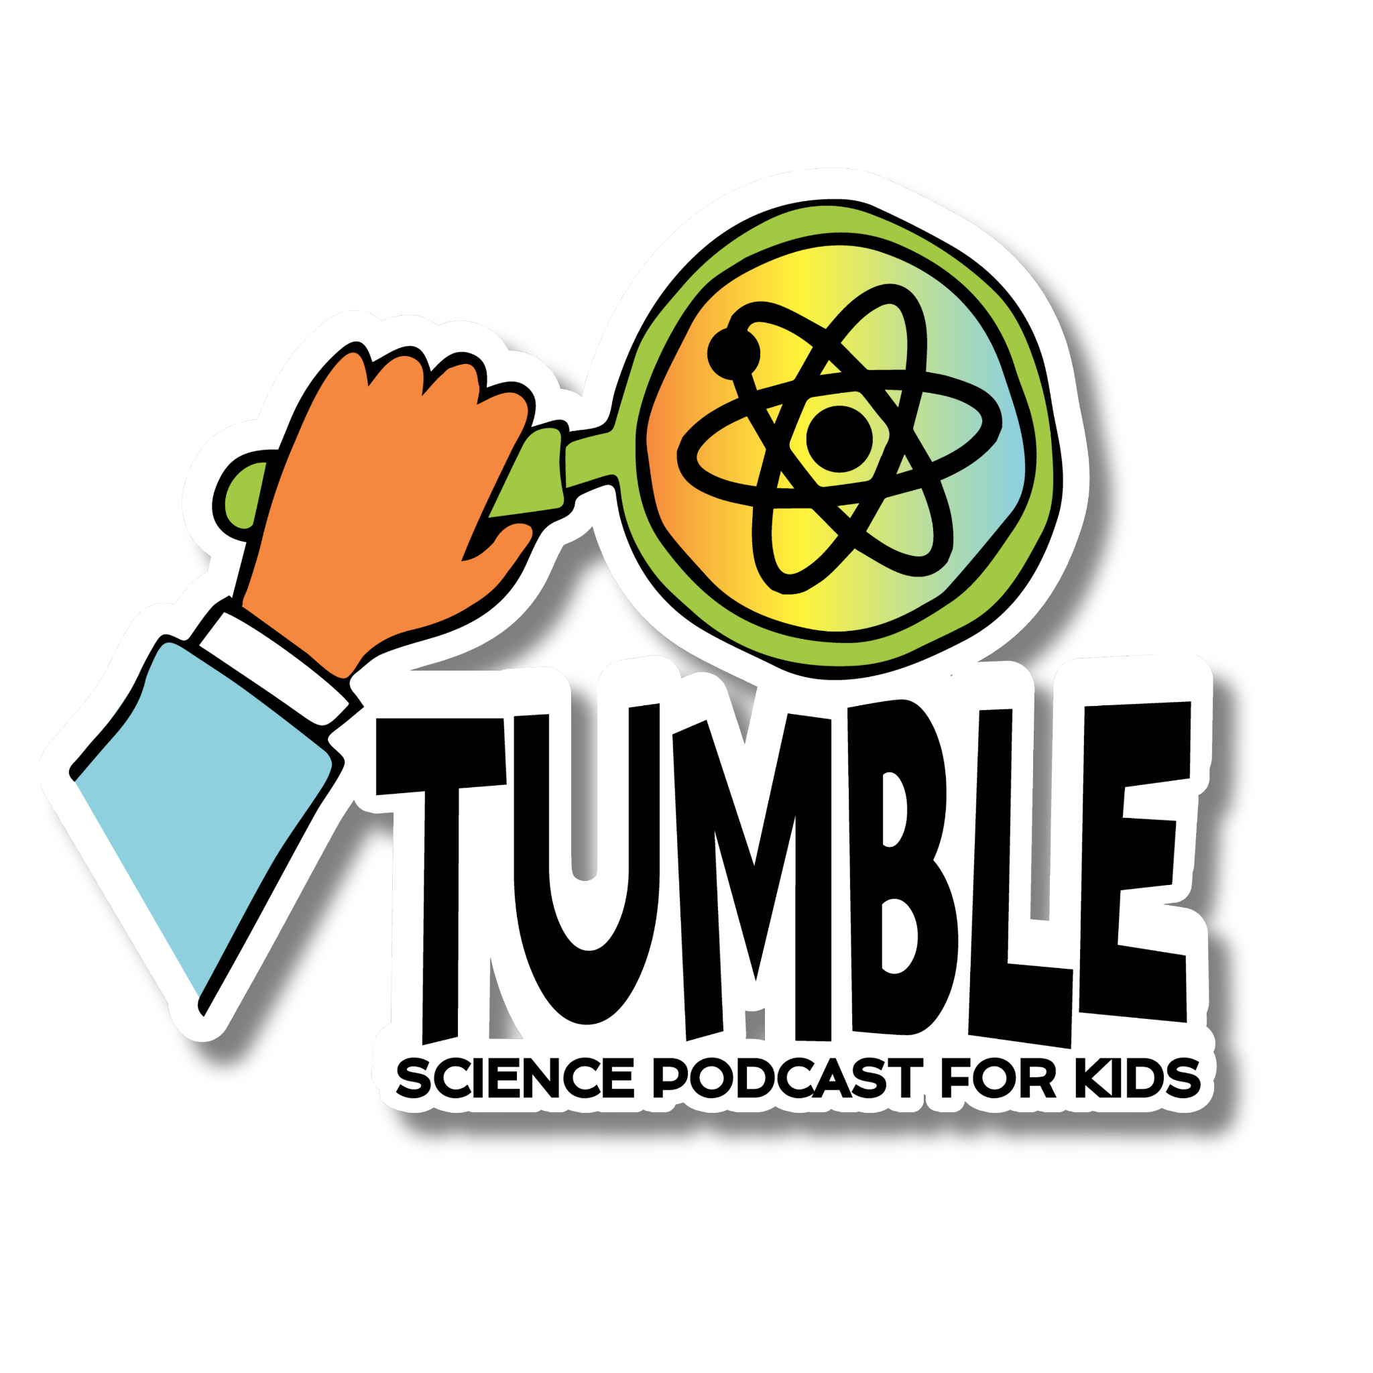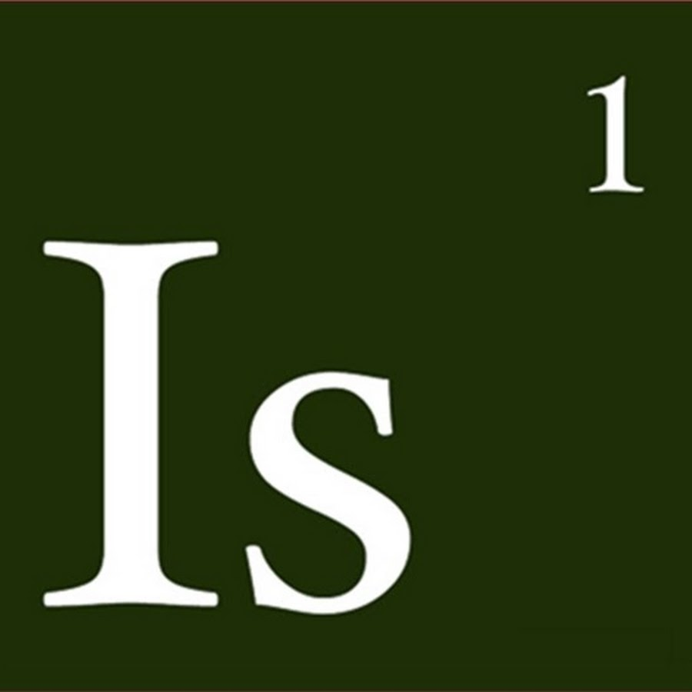

# 

# Introduction to the Episode

Welcome to the Tumble Science Podcast for Kids Classroom Resource Packet for "The Science of Ocean Sounds"! This packet is designed to provide upper elementary school teachers with engaging and educational materials aligned with national standards. Through listening and hands-on activities, students will explore how sound is used to study the ocean and understand complex scientific concepts.

This podcast episode is about Dr. Amy Bower, an oceanographer who spends her time learning about massive rivers of water in the ocean called ocean currents. In this episode, Dr. Bower will talk about how she seeks to answer big questions about the ocean, and how she uses technology to help her identify patterns in the data she collects. You’ll also go on a sound scavenger hunt as you listen!

 **Resources:**

* **Episode Blog Post:** Listen to the published episode and find additional links on the [blog post](https://www.sciencepodcastforkids.com/single-post/the-sounds-of-ocean-science) for the episode.
* **Episode Download:** Click here to download an [ad-free version](https://www.dropbox.com/scl/fi/zst6f0z6o4nuvtq6cbz1p/The-Science-of-Ocean-Sounds_whole.mp3?rlkey=hpkwugnphbn35tzunrbpuhi18&st=t4vpixvv&dl=0) of the episode “The Science of Ocean Sounds with Amy Bower,” or listen on [YouTube](https://www.youtube.com/watch?v=fIEPPBj5QVs&t=1s)
* **Transcript:** Click here to download a [transcript](https://drive.google.com/file/d/1wvGU7IlhMiPcTH1jVVfonkQVAyQlTmsx/view?usp=share_link) of the episode

# 

# How to Use this Packet in Class

There are a number of different ways teachers might integrate podcasts into their classroom routines, and Tumble in particular. How you choose to do this informs how you would use these resources. Here are a couple suggestions for how you might use a podcast in your classroom:

* **Listen Actively:** Play the episode in “chunks,” using the provided listening guide and encourage students to take notes using the graphic organizers.
* **Discussion:** Use the guided questions to spark conversations about the concepts explored in the episode.
* **Hands-On Activities:** Engage students with hands-on experiments that reinforce the episode's themes.
* **Cross-Disciplinary Learning:** Incorporate literacy, math, and social-emotional learning through connected activities.

**Actively Listen to the Episode in Class:**

We have heard from multiple teachers who play an episode of Tumble for the whole class as part of a regular lesson, and have the students follow along. Here are two suggestions to help retain student attention while listening to the full episode:

1. Use the listening guide included in this resource package to keep students engaged in listening, or design your own resources (graphic organizers, doodling sheets, etc.)
2. Break the listening up into chunks of about 2-3 minutes.

This episode has a run time of about 20 minutes. so you’ll want to break it up with lots of discussion. We’ve provided a version of the episode that is already divided into several “chunks” for this purpose.

** Resources:**

* **Excerpted Episode:** Click this link to download an [excerpted](https://www.dropbox.com/scl/fo/s0stosoqqhjob5oxdgiq0/h?rlkey=od7vb4t7wunfaz9kxk1wtbj9r&st=i64s92kx&dl=0) version of the episode, divided into 7 chunks, complete with descriptions of each section. You can also use the chapters listed on the [YouTube version](https://www.youtube.com/watch?v=fIEPPBj5QVs&t=1s) of the episode.
* **Listening Guide**: Use [this link](https://drive.google.com/file/d/1aLTD3L3olj9ebPvgWod1WvLLeGg2Zc1h/view?usp=share_link) to get the listening guide for students to use while listening.

**Assign the episode instead of reading:**

This is a great idea for students who struggle with reading. If you want them to learn about the water cycle, instead of having them read an article about it, play this episode! It’s quicker, it’s enjoyable, and it allows students to learn the science content without also having to struggle with reading. Assign the students to listen to this episode, share it on your class site, and assign both a pre-listening activity (ideally done during the school day), and a post-listening activity (done either the next day or at home). If you give multiple options for homework assignments, listening to a podcast is a great option.

**Listen to the Episode Over Several Lessons:**   
You can break up listening to this episode into several short sessions, assigning each section, over the course of a week or two weeks. This could be done in conjunction with some of the activities we’ve included in this resource package.

**Play the episode in the background while students are doing other activities:** Podcasts can be a great companion to classroom cleanup, art activities, transitions, and so on. Podcasting is ideal for activities where the hands are busy but the language centers of the brain are not - leaving kids free to listen and engage. If you do this, you may wish to reinforce some of the concepts discussed in the episode with a pre- and post- listening activity.

# NGSS and Common Core Connections

This resource package has been aligned with the following national education standards:

**ESS2.B: Plate Tectonics and Large-Scale System Interactions**

* + Maps show where things are located. One can map the shapes and kinds of land and water in any area.
  + The locations of mountain ranges, deep ocean trenches, ocean floor structures, earthquakes, and volcanoes occur in patterns. Most earthquakes and volcanoes occur in bands that are often along the boundaries between continents and oceans. Major mountain chains form inside continents or near their edges. Maps can help locate the different land and water features areas of Earth.

| **Common Core:**  ELA/Literacy - | |
| --- | --- |
| [RI.4.7](http://www.corestandards.org/ELA-Literacy/RI/4) | [Interpret information presented visually, orally, or quantitatively (e.g., in charts, graphs, diagrams, time lines, animations, or interactive elements on Web pages) and explain how the information contributes to an understanding of the text in which it appears.](http://www.corestandards.org/ELA-Literacy/RI/4) |
| [W.4.7](http://www.corestandards.org/ELA-Literacy/W/4) | [Interpret information presented visually, orally, or quantitatively (e.g., in charts, graphs, diagrams, time lines, animations, or interactive elements on Web pages) and explain how the information contributes to an understanding of the text in which it appears.](http://www.corestandards.org/ELA-Literacy/W/4) |

**Cross Cutting Concepts:**

*Patterns -*

* In the episode, Amy discusses using sound to represent data, and how sound (or data sonification) can help her identify patterns
* The hands-on activities we’ve included are designed to guide students to identify patterns in data

*Scale and Proportion -*

* At the beginning of the episode, Amy discusses growing up near the ocean and how it inspired to ask questions about how the ocean works. But what she studies as a scientist exists at a completely different scale, which she can’t observe just by watching the waves. We have to look at the ocean system at a different scale to see the data patterns that show where the ocean currents are.

*Systems and System Models -*

* Amy’s work involves the creation of maps of large scale ocean currents. She’s trying to understand how the currents impact the ocean’s systems by building a model of the currents. Mapping the ocean floor is important and useful. Amy’s drifting buoys and beacons allow the mapping of the ocean water movements, and she needs data to build the map.
* Amy’s use of sonification to represent the data she collects is use of a *system* that helps her better understand a natural phenomenon.
* As one part of the ocean system changes, it impacts the others. Amy’s work is meant to understand how this system works as a whole.

**SEL Connections**

Data analysis using “graphs” is challenging for blind scientists. What other ways are systems we are familiar with challenging for people who are blind or low vision? What other systems might be made easier through the use of sound? (Can you feel empathy for the challenges of blind and low vision people who need to work in a system that is designed for sighted people?)

# Lesson Plan

**Overview**

In this lesson, students will listen to an episode of *Tumble Science Podcast for Kids* and use that as a jumping-off point for learning more about how scientists study the ocean. After learning how Amy uses buoys and sound to study ocean currents, they will conduct an investigation of their own to learn more about how to use data to map phenomena in the ocean.

| **Grade Level** | **Time Allotment** |
| --- | --- |
| **3 - 5** | 2-3 Classroom Days |
| **Learning Objectives** | |
| * Students will understand how scientists use data to explore ocean currents and make maps of the ocean * Students will be able to model ocean currents and depths using maps and data | |

**Next Generation Science Standards (NGSS)**

* ESS2.B: Plate Tectonics and Large-Scale System Interactions
* Crosscutting Concepts: Patterns, Scale, and System Models

**Common Core Standards**

* ELA/Literacy RI.4.7: Interpret information presented in various formats.
* ELA/Literacy W.4.7: Conduct short research projects that build knowledge.

**Prep for Teachers**

**Before the Lesson**

1. Make sure students have the ability to listen to podcast excerpts
2. Print out lesson handouts
3. For the investigations:
   1. Shoebox Investigation:
      1. Prepare shoeboxes according to the instructions
   2. Beacon / Buoy Activity:
      1. Print out and cut out for student tokens, or use your own tokens, 10 tokens per student
      2. Prepare ~10 buckets or containers, to place at key locations around your classroom

**Student Supplies**

* Computer or tablet access
* Headphones

**Handouts for Students**

* Podcast Listening Resources
  + [Listening Guide](https://drive.google.com/file/d/1aLTD3L3olj9ebPvgWod1WvLLeGg2Zc1h/view?usp=share_link) for students, contains background information, KWL chart, listening questions, discussion questions, graphic organizer, more
  + [Transcript](https://drive.google.com/file/d/1aLTD3L3olj9ebPvgWod1WvLLeGg2Zc1h/view?usp=share_link) (also on [blog](https://www.sciencepodcastforkids.com/single-post/the-sounds-of-ocean-science))
  + Hands on Activity Handouts (See below)
* Additional Resources / Videos on [our website](https://www.sciencepodcastforkids.com/single-post/the-sounds-of-ocean-science)

**Seafloor Mapping Activity Supplies**   
(courtesy of forsea.org – see attached [lesson plan](http://www.forsea.org/wp-content/uploads/2019/08/F9U5A2TGST.pdf))

* 1 shoe box (or other sized box) model with lid, sealed with masking tape, and with a grid of holes on top of lid
* 1 bamboo probe, or the equivalent, to be used in sounding the model
* 2 copies of all student pages
* plenty of 1/4" quadrille graph paper
* tag board or old manila folders for mounting cut-out graphs
* large (11"x17" min.) sheets of drawing paper or tag board for topographic maps
* tape for fastening graphs to tag board

**The Teacher is the Beacon, the Kids are Buoys Activity Supplies**

* Poker chips, cardboard cutouts following a template, playing cards with different-colored backing, or some other small item students can carry around to record their movements, or use the printouts on this [PDF](https://drive.google.com/file/d/1naNUf4uA_nTa6WJdji5ikNiSl482Yuqr/view?usp=share_link) glued to cardboard or similar
* Ten buckets or other small containers
* Data recording sheets and student handouts
* A noise maker of some kind (bell, whistle, other sound maker for the “beacon” signal)

** Resources**

1. Print Outs for Beacon Activity ([PDF](https://drive.google.com/file/d/1naNUf4uA_nTa6WJdji5ikNiSl482Yuqr/view))

## **Learning Activities:**

### Engage ( 10 - 15 minutes)

1. **Listen** to the opening segment of “Science of Ocean Sounds.” [[Dropbox](https://www.dropbox.com/scl/fi/5gme05iaovlxfxo65leoy/Introduction-00.00-02.18.mp3?rlkey=ihxynrjjjfxyef5bwi9bkzrfl&dl=0)] [[YouTube](https://www.youtube.com/watch?v=fIEPPBj5QVs)]
2. **Facilitate a discussion:**

* What do the kids think the sounds on the “scavenger hunt” are?
* Ask kids what they already know about the ocean, what do they think these sounds could have to do with these things they already know?
* Have students make predictions about what they will hear in the rest of this episode

1. **Writing Activity:** After listening to the excerpt, have students write down some of their predictions: what are each of the three sounds?

* Ask them to support their reasoning with evidence. Can they clearly explain why they think what they think?
* Consider a “Claim / Evidence / Reasoning” format to guide students’ writing
* Using a K-W-L chart, have students write down what they already know about the ocean and what they want to learn

### Explore - (time estimates below)

1. **Listen** to the next four episode excerpts
   1. What is an ocean current part 1 - 02:18 - 03:37 (leaves with Amy learning about Ocean currents without defining [[Dropbox]](https://www.dropbox.com/scl/fi/ln6wkdgt8m6xlozsyei9m/What-is-an-ocean-current-part-1-02.18-03.37-leaves-with-Amy-learning-about-Ocean-currents-without-defining.mp3?rlkey=wjagiw8qiezgacqb3qn50jsa9&dl=0) [[YouTube]](https://www.youtube.com/watch?v=fIEPPBj5QVs)
   2. What is an ocean current part 2 - 03:37 - 04:36 [[Dropbox]](https://www.dropbox.com/scl/fi/4470ugrwre88wvnykv9zw/What-is-an-ocean-current-part-2-03.37-04.36.mp3?rlkey=ntocwftj0ehovo7yzkp09mqra&dl=0) [[YouTube]](https://www.youtube.com/watch?v=fIEPPBj5QVs&t=138s)
   3. What Amy wants to know about the Ocean and how she finds out - 04:36 - 08:15 [[Dropbox]](https://www.dropbox.com/scl/fi/xmhw30vo93dp3jczxchcy/What-Amy-wants-to-know-about-the-Ocean-and-how-she-finds-out-04.36-08.15.mp3?rlkey=9uzzi0fo0498m65ml6lsfk81z&dl=0) [[YouTube]](https://www.youtube.com/watch?v=fIEPPBj5QVs&t=276s)
   4. What Amy found out from Buoys - 08:15 - 10:04 [[Dropbox]](https://www.dropbox.com/scl/fi/dsg7rv34ng7hc7ad3zor1/What-Amy-found-out-from-Buoys-08.15-10.04.mp3?rlkey=syfhoxle16ybbhqk9jwvvu34b&dl=0) [[YouTube]](https://www.youtube.com/watch?v=fIEPPBj5QVs&t=495s)
2. **Discuss:** After listening to each excerpt, discuss with your students - what was Amy trying to find out? How did she learn what was in the oceans?
3. **Activity:** As students listen through to the content, they can identify each of the items in the “Sound Scavenger Hunt.”
   * The first sound can be heard in the third excerpt–it’s the sound emitted by a drifting buoy.
4. If your students would like to continue listening, continue on to the next section of the lesson plan. Alternatively, this could be a good moment to introduce the students to an investigation of their own. “We’re going to conduct one of two investigations to help answer the question: how can we make a map of the ocean when we can’t see everything that goes on out there?”
5. **Investigations:** Conduct one of the following investigation activities.

Investigation: “[Seafloor Mapping Shoeboxes](http://www.forsea.org/wp-content/uploads/2019/08/F9U5A2TGST.pdf)” (1 hr or more, depending)

* Provide students with closed shoebox kits with various items inside
* The shoe box lid has holes in the top
* In groups of 2 to 4 students, have them measure how deep a bamboo stick can fit through the hole and collect data at each spot
* Using their depth “soundings,” can they construct a map of the “seafloor” inside their shoebox?
* How does this relate to Amy’s work mapping the ocean?

Investigation: The Teacher is a Beacon, the Kids are Buoys - (1 hr or more, depending)

* Activity Instructions can be found [here](https://docs.google.com/document/u/0/d/1FKJvh4sBRvmP-CgrsfGe5XnKXDAn35JJooCc-tFAkFE/edit), and printouts for the activity are included [here](https://drive.google.com/file/d/1naNUf4uA_nTa6WJdji5ikNiSl482Yuqr/view?usp=share_link). .
* Give each student 10 “tokens,” each one numbered 1 through 10
  + Tokens can be numerous different things–playing cards, poker chips, or cardboard cutouts in different shapes, one shape per student
  + Printable PDF of tokens of different shapes for each stop is included in this resource package
* Place 10 buckets in key locations around your classroom
* Over the course of either an hour or a full class day, the teacher sends out a signal (either a whistle, bell ring, or simply a call from the teacher) that is meant to mimic the behavior of the beacon, sending its signal to the various buoys
  + Each time the signal is given, the students should find the nearest bucket or container, and drop their numbered token into the bucket
  + Beacon signals should be sent out periodically. For example, if performed over the course of an hour, each “signal” should come about every 6 minutes; if over the course of the day, once every 45 minutes.
  + One or more students should record the time that the “signal” occurred
* At the end of the hour / day, students analyze the data. Some suggestions:
  + Students could look at each bucket in isolation, counting up the number of tokens in each bucket. What does that reveal about the patterns of student movement in a classroom?
  + Students could look at their own individual progress through the classroom over the course of the period. Using map worksheets (provided), could mark their movement through the class and draw their “current” by connecting dots between each bucket’s location. What does this pattern reveal about the way they move through their day? Can they explain the data they see?
  + This activity could be done over the course of multiple class days, allowing students to observe how movement through the classroom changes over time.
  + Students could discuss different ways to visualize or sonify the data collected. What would be the most interesting and useful way to show the patterns they’ve found in the data?
  + Some suggested ways for students to interact with the data:
    - Knowing the locations of each of the buckets, can they make a map of their movements in the classroom over the course of the day? Can they explain why they were at certain locations at certain times?
    - Did some buckets have more tokens in them than others? Why would that be?
    - Did everyone in the class have the same pattern of movement over the course of the day? Why might some people’s movements be different from others?
    - How would this map look different if we’d done this investigation on a different day?
  + Draw connections to Amy’s work in the ocean:
    - How was this activity similar to Amy’s work mapping ocean currents?
    - What challenges with mapping ocean currents did we learn about?

### Explain - 15-20 minutes

* Listen to remaining episode excerpts on data sonification
  + What is Data Sonification - 10:04 - 13:14 [[Dropbox]](https://www.dropbox.com/scl/fi/0k4y4aqd6n9nwvmzbhgeo/What-is-Data-Sonification-10.04-13.14.mp3?rlkey=4cks6kwvsr8vlhnit8opvd1i5&dl=0) [[YouTube]](https://www.youtube.com/watch?v=fIEPPBj5QVs&t=602s)
  + Sonification and an Underwater Volcano - 13:14 - 16:10 [[Dropbox]](https://www.dropbox.com/scl/fi/5u0eqyolyw1eq7t07yxdx/Sonification-and-an-Underwater-Volcano-13.14-16.10.mp3?rlkey=agrn60johyrx4e4ovmtvgh1ho&dl=0) [[YouTube]](https://www.youtube.com/watch?v=fIEPPBj5QVs&t=771s)
  + Advantages to Data Sonification and end credits - 16:10 - 20:15 [[Dropbox]](https://www.dropbox.com/scl/fi/6x9e4zrq70ikbhe1ko8nd/Advantages-to-Data-Sonification-and-end-credits-16.10-20.15.mp3?rlkey=1tdxegegq2brfm2yj6dk9sv96&dl=0) [[YouTube]](https://www.youtube.com/watch?v=fIEPPBj5QVs&t=958s)
* The remaining scavenger hunt sounds will be revealed in these excerpts.
  + Sound #2 is in the first excerpt “What is Data Sonification”
    - The sound is Amy singing an example of what her data might sound like
  + Sound #3 is in the second excerpt “Sonification and an Underwater Volcano”
    - The sound is a sonification of a seafloor rise during an underwater volcano eruption
* If you performed one of the two investigations, discuss with your class how we can use what we learned about how Amy uses sound to represent data to work with our own data. What are other ways besides just drawing a graph that we can show what we’ve collected?
* Discuss the relevant concepts with students. How did our exploration address the things that Amy was concerned with in the episode? What did we learn about mapping the ocean?

### Elaborate (20 minutes)

* Discuss with students: are there ways we can show the data we’ve collected that might better reveal the patterns we’ve discovered?

### Evaluate (15-20 minutes)

* Class discussion, reflecting on the activity and the episode
  + What did we learn about seafloor mapping?
  + Why are these techniques important or interesting?
  + Were there predictions we made at the start of class that were incorrect, or ways that we’ve changed our mind after performing this investigation?

## The Science of Ocean Sounds - Listening Guide

### PART 1: Before Listening to the Podcast

1. Complete this chart and discuss

| **K - What you Know about the Ocean** | **W - What you want to know about the ocean** | **L - What you’ve learned about the ocean** |
| --- | --- | --- |
|  |  |  |

### 

Now, listen to the [first excerpt](https://www.dropbox.com/scl/fi/5gme05iaovlxfxo65leoy/Introduction-00.00-02.18.mp3?rlkey=ihxynrjjjfxyef5bwi9bkzrfl&dl=0) and answer the following questions:

1. What do you think each of the three sounds from the scavenger hunt are? Use evidence and explain your reasoning.
2. In the podcast, Lindsay gives the hint that “One of the sounds is used to collect data about the ocean and the other two are used to help understand the ocean.” What do you think she means by that?
3. Why do you think it’s important to study the ocean? What do you think we can learn by collecting data about the ocean?

### PART 2: Sound Scavenger Hunt

At the start of this episode, you hear three sound effects. As you listen to the episode, you’ll learn what each of these sounds are. Use this sheet to help you complete the sound scavenger hunt as you listen!

| How would you describe the sound? | What do you think the sound was? | What **evidence** makes you think that? | Explain your **reasoning** |
| --- | --- | --- | --- |
|  |  |  |  |
|  |  |  |  |
|  |  |  |  |

As you listen and find out what the sounds were, use the chart below to take notes.

| Describe the sound here | What was this sound? | What did the sound have to do with Amy’s work? | How does the sound help scientists understand the ocean? |
| --- | --- | --- | --- |
|  |  |  |  |
|  |  |  |  |
|  |  |  |  |

### 

### PART 3: Checking for Understanding

Answer these questions as you listen to the episode. Discuss them with a partner afterwards and see if you agree on the answers!

1. What is an ocean current?
2. How big are some of the biggest currents in the ocean?
3. What is the purpose of Amy’s drifting buoys? How does Amy use them to learn about ocean currents?
4. What does *data sonification* mean? What are some examples Amy gives in the episode? What are some advantages to sonification over other forms of representing data?
5. Once you’ve finished listening to the episode, what were each of the three sounds given in the scavenger hunt?

**Discussion Questions**

1. Amy’s journey of learning about the ocean began when she was a young child. What’s something you wonder about now that you might want to study more in the future?
2. Amy mentions how sonification has helped her as a blind scientist to better understand the data she needs to use to learn about the ocean. Can you think of other ways besides sound that scientists might be able to represent data to help them understand the world around them? What might be the advantages and disadvantages of each method?
3. On your KWL chart, what is something new that you learned after listening to the Tumble Science Podcast episode “The Science of Ocean Sounds?”

**Graphic Organizer**

Use the following chart to help you take notes as you listen to the episode. In the left-hand column, write down things that you learned from the episode. In the right hand column, write down questions you still have about each of the facts you wrote down. What more would you like to learn?

| Fact About the Ocean | Questions |
| --- | --- |
|  |  |

# Interdisciplinary Connections & Additional Resources

**Interdisciplinary Connections & Other Podcast Episodes**

* [“Ep. 24: Shipwrecks!” - *The Past and the Curious*](https://thepastandthecurious.com/episodes/ep-24-shipwrecks-ep-24-shipwrecks-ida-lewis-marquis-de-lafayette-sail-away-ladies/)*.* Join host Mick Sullivan and friend Hanna Zimmerman of Locust Grove as we share the stories of Marquis de Lafayette's steamboat shipwreck, and Rhode Island lifesaver Ida Lewis. Also features a performance of the song "Sail Away Ladies," Quiztime and more! Interdisciplinary connections: history, social studies, mapping, explorations
* [“Why the Ocean is Salty” - *Circle Round.*](https://www.wbur.org/circleround/2017/09/26/why-the-ocean-is-salty-circle-round)Rebecca Sheir re-tells this folk tale from the Philippines with help from actors Lou Diamond Phillips and Jon Jon Briones. This folk tale can combine with the science in the Tumble episode to provide students with additional context for investigating explanations for natural phenomena. Interdisciplinary connections: folk tales, ELA, creation myths.

**Other episodes of Tumble about the Ocean:**

* [How to be an Ocean Explorer](https://www.sciencepodcastforkids.com/single-post/how-to-be-an-ocean-explorer)
* [The Great Seal Count](https://www.sciencepodcastforkids.com/single-post/the-great-seal-count)
* [The Expedition of the Science Ship](https://www.sciencepodcastforkids.com/single-post/2019/11/01/the-expedition-of-the-science-ship)

**Books and Further Reading:**

* [*Giant Squid* by Candace Fleming](https://www.amazon.com/Giant-Robert-Sibert-Informational-Awards/dp/1596435992) - The Giant Squid details, through text and drawings, the structures of the giant squid that lives deep in the ocean where light is not available. The text uncovers many of the squid’s structures and why they allow the squid to move, eat, reproduce, and survive. Also available as an audio book. Read-aloud version on YouTube, [here](https://www.youtube.com/watch?v=9bHXZUVrJfI).
* [*The Shark Lady* by Eugenie Clark](https://www.amazon.com/Shark-Lady-Eugenie-Fearless-Scientist/dp/1492642045/ref=sr_1_1?crid=2R9GPEH1WSS7M&dib=eyJ2IjoiMSJ9.N7dfNFpfLBEyGFbJsUUDjXz3Ao0cZuT05rcmh8Un0vh7zROnMogOFr8PsjAnHAfr--_bko-T37GRtfsScV7wo9pIFXlI8Rrv3EFaoP4iU-5r1mfBoyinphQKeRfrOVHdLRKjvTA66Rgb-wl1BlMfPWdNOTDdFReQD9xFJDugKbVgwVzyhN-jFgtlaihOvEzsYIrwjj4A5hv2DKrjpkhCZ-nMbOwCsmZetAoZ-056byQ.y1WR1WqED1H6IpW16gshTL2Wq45AFGJvfSSFLrGfaGs&dib_tag=se&keywords=the+shark+lady+eugenie+clark&qid=1714761621&s=books&sprefix=the+shark+lady+eugenie+clark%2Cstripbooks%2C123&sr=1-1) - This biography of Eugenie Clark follows her life from childhood through earning respect in her work learning about sharks. Both the pictures and the text provide information to the reader. Also available as an audio book.

# Full Transcript: “*The Science of Ocean Sounds”*

 **Resources:**

* **Episode Download:** Click here to download an [ad-free version](https://www.dropbox.com/scl/fi/zst6f0z6o4nuvtq6cbz1p/The-Science-of-Ocean-Sounds_whole.mp3?rlkey=hpkwugnphbn35tzunrbpuhi18&st=t4vpixvv&dl=0) of the episode “The Science of Ocean Sounds with Amy Bower”
* **Transcript:** Click here to download a [transcript](https://docs.google.com/document/d/1LQU5atEbL0MxqoqGLez7X0xZNIH4LtYyXRGzYv1-szo/edit?tab=t.0) of the episode

LP: Hi I’m Lindsay.

ME: And I’m Marshall. Welcome to Tumble, the show where we explore stories of science discovery.

LP: Today, we’re exploring the sounds of ocean science.

ME: What kind of sounds? Waves? Bubbles? Fish singing?

LP: Sounds like this: *(MUSIC STOPS)*  
  
SFX: Underwater volcano

ME: Whoa, what is that?   
  
LP: We’re about to go on a sound science scavenger hunt to find out.

*MUSIC*

ME: Okay what was going on with that sound? It sounded like I was in the wheel of a bulldozer.

LP: You mean this sound?

SFX: Underwater volcano

ME: Yeah! What is it?   
  
LP: Hmmm. I don’t think I’m going to tell you just yet.

ME: Is this one of those mysteries where I’m going to have to figure it out on my own?

LP: It is! Because it’s a sound scavenger hunt episode.

ME: Alright! Scavenger hunts. Is this where we go house to house looking for clues?

LP: You can stay in the same place because we’re going to use our ears. So here’s the setup. We’re about to meet a scientist who uses sound to study the ocean. And I’m going to play a few of the sounds that we’ll be searching for throughout the episode. So listen carefully. Here’s the first sound:

SFX: Sound beacon

ME: All right, that is a sound.

LP: Here’s the second:   
  
SFX: Sonification tones  
  
ME: Ooookay

LP: Here’s the last:   
  
SFX: Underwater volcano  
  
ME: I’ve already asked about this one - what is it?

LP: All will be explained, soon. But I’ll give you one tiny little clue. One of the sounds is used to collect data about the ocean and the other two are used to help understand the ocean.

ME: Okay… that’s not much of a clue.

LP: That’s all I’m giving you to go on. So are you ready to start?

ME: Sure!

LP: Okay great. Let’s meet the scientist behind the sounds. Her name is Amy Bower.

Amy Bower: I'm a scientist who is trying to understand how the oceans work. Specifically, I'm trying to map out all the ocean currents right down to the bottom of the ocean - from top to bottom.

ME: So she’s like an ocean map maker!

LP: Amy is an oceanographer!

ME: It just makes so much sense.

LP: Amy has always been curious about how the ocean works since she was little.

Amy Bower: I grew up on the ocean, so, you know, I was naturally very interested in what the ocean was doing all the time. Why are those waves bigger today? Why? Why? What makes the tides work?

ME: So basically, she was observing the ocean - like a kid ocean scientist!

LP: Yeah! But years later, when Amy was in school to become a scientist, she discovered something about the ocean that would fascinate her for decades.

Amy Bower: That's when I first started to learn that there were these giant rivers in the ocean, otherwise known as ocean currents that carried huge volumes of water - of seawater - all around the globe. I had no idea that was true before then. And I just thought that was awe-inspiring.

ME: Wait, there are giant rivers in the oceans? How can there be rivers in a body of water?

LP: Ocean currents are patterns of fast-moving seawater, powered in part by the wind.

Amy Bower: So the water next to the current is not moving that much. And then you have a strip of ocean that is moving pretty quickly.

ME: How big are these currents? Are we talking big river? Or narrow stream?   
  
Amy Bower: Some of the biggest currents in the ocean are equivalent to a thousand Mississippi rivers.

ME: So like, one Mississippi is pretty big. Then you’ve got two Mississippi, three Mississippi…

LP: By the time you get to a thousand Mississippi, it’s a lot of Mississippi.

ME: That’s a mind-boggling amount of water.

LP: What’s even more mind-boggling is how little we know about these currents.

Amy Bower: Part of what I'm trying to understand is where are all of the currents? You know, where are they anyway? And, how strong are they? What path do they follow? There are many questions like that that we don't have answers to yet in the deep ocean. So we don't even understand yet how our ocean functions, in many respects.

LP: That’s why Amy is making a map of ocean currents. It will help us understand how the ocean works - and its flow affects our climate.

ME: So how does Amy make that ocean current map?

LP: Using sound.

ME: Ooh I feel like this might be a clue to our scavenger hunt.

LP: Maybe! So first, Amy heads out into the ocean.

Amy Bower: Oceanographers like me, many of us go out on these ocean expeditions.

ME: Ooh adventure on the high seas!

LP: A big research ship takes Amy and her colleagues to places where she wants to map the currents. Once they’re there, they take out a special buoy - a container designed to float underwater - and capture data about the water’s temperature, speed, direction, and more.

Amy Bower: We just drop those over the side, they sink down to the depth of the current that we want to investigate, and then they, we just go away and they drift.

ME: Wait, they just drift out on their own?

LP: These buoys act like explorers, following the currents and keeping a log of their travels. And scientists track them using sound.

Amy Bower: At the same time, we put the buoys out, we anchor the sound beacons in the general area where we think the buoys are gonna drift. Those sound beacons emit a sound.

SFX: Buoy sound

ME: I got it! That’s one of the sounds we were listening for!

LP: Yes! It's a signal that communicates with the drifting buoys in the ocean.

SFX: Buoy sound

Amy Bower: So several times a day they send out this signal, and the drifting buoy has a hydrophone, which is like a microphone for underwater.

ME: Wait, does it do an underwater podcast?

LP: It’s really more of a “listening” microphone and the buoy sound is kind of like the speaker.

Amy Bower: The hydrophone on the drifting buoy is listening for just this particular signal.

LP: The instruments inside the buoy records the time it hears the signal.

Amy Bower: So we know how long it took the sound to go from the sound beacon to the drifting buoy. We also know the speed of sound in water.

LP: Using some simple multiplication, Amy can figure out the distance between the sound beacon, and the drifting buoy.

ME: So the sound beacon is tracking the drifting buoy.

LP: Yeah. And there’s a bunch of these sound beacons anchored to the ocean floor. So it’s sort of an ongoing game of Marco Polo, as the buoy moves through the current.

Amy Bower: So we have to have two parts to this system. There's the drifting buoy itself, plus the sound beacons.

LP: Using sound, Amy can pinpoint the position of the buoy, and map its movements across the ocean.

ME: So that’s how she makes the ocean current map! So what has she found so far?

LP: She’s found that ocean currents do some unusual things. For example, Amy told me about the time she used two of these buoys to study a mysterious current off the coast of Spain and Portugal.

Amy Bower: After about a year, each one of those buoys popped up to the surface and gave us the data. And then we were able to reconstruct where each buoy went while it was underwater in this current.

LP: The buoys had some surprising information to share. The data showed that the current didn’t follow the path that Amy thought it would. Instead, it broke into pieces.

Amy Bower: And these are not small pieces. These are big pieces that are maybe 50 miles wide and circular. We call them eddies, a sort of swirling vortex.

LP: They discovered these eddies can capture warm seawater, and transport it all the way across the Atlantic, like little swirling islands.

ME: So currents aren’t just rivers, they’re also islands? That’s bizarre.

LP: Totally. But like Amy says, we can’t see how the ocean works - bit by bit, sound is revealing what’s deep beneath the waves.

ME: Yeah because let’s face it - moving water in more water is essentially invisible.

LP: And that’s not the only way that Amy’s using sound to study the oceans. After this quick break, we’ll find out how Amy uses sound to understand her data - and why she wants to share it with everyone.

AD BREAK

LP: We’re back and continuing on our scavenger hunt! So you heard how Amy uses sound to map ocean currents. But she also uses sound to understand the data - and share it with others.

Amy Bower: I'm doing some exploration of how we can use sound to “visualize” data.

ME: “Visualize data?” Is she talking about using *sound* to be able to *see* what the data is telling us? I’m confused.

LP: Yeah. So usually, scientists turn the numbers from their data into visual forms like charts and graphs. But that doesn’t really work for Amy.

Amy Bower: I'm a blind scientist, so in fact, the data I'm collecting and measuring, is now pretty difficult for me to see on a graph.

LP: Amy became blind while she was training to become an oceanographer. So that led her to experiment with something called “data sonification.”

Amy Bower: Data sonification - it's a big word - is basically just translating numbers into sound.

ME: Whoa that sounds really interesting. So is it like, each number is a sound?

LP: That’s the basic idea! Each number is assigned a frequency - or pitch. Here’s how Amy describes how it works.

Amy Bower: So you say okay, I'm gonna give that the frequency that sounds like, “Ooh”, okay? So every time the number two comes up, there'll be a “ooh” sound coming from my computer.

Amy Bower: Then I say, okay, the number four, we're gonna have, ooh, (higher pitch) okay? So every time number four comes up, the sound “ooh” will be played by my computer.

Amy Bower: So if you were just switching back from two to four to two to four, go, “ooh, ooh, ooh, ooh.”

Amy Bower: Now I usually have a lot more numbers than just two to four, right? I got a whole bunch of numbers. And so you end up with something that might sound sort of like, ooh (sings long, varying pitch)

Amy Bower: And that's telling me that the numbers are changing a lot across a particular range.

ME: Oh man. That’s so cool. So instead of seeing numbers go up or down in a graph, you actually *hear* them. But did I hear one of our scavenger hunt sounds in there?

LP: You did! It’s Amy singing her numbers. It’s just one example of how data could sound.

Amy Bower: There are other much more sophisticated ways where you could say, use different instrument sounds to represent different types of data.

LP: Say, wind data could be a wind instrument, and ocean data could be a horn.

SFX: Wind instrument and horns

ME: I’m getting excited - you could have a whole chorus or orchestra of data!

LP: Yeah. There are some really cool projects that play with data sonification. There are a lot of cool projects to share the sounds of data. Amy’s working on one for an underwater volcano. Do you want to hear what it sounds like?

ME: Yes of course.

SFX: Underwater volcano.

ME: We found all three! That’s our second sound from the beginning of the episode!

LP: You got it. This data comes from a sensor that measures pressure, or force, beneath the seafloor - right next to an underwater volcano.

Amy Bower: It turns out that this volcano erupts every now and then - maybe every few years, five years or so. When it's not erupting, the magma is building up under the sea floor. And the sea floor is slowly rising, being pushed up by the magma underneath.

ME: Wait so the seafloor itself actually moves up?

LP: Yes! The sensor measures that movement.

Amy Bower: If you are a visual person in a visual display, you can see this rise and fall of the sea floor. But if you're not a visual learner or you're visually impaired, you can't see that.

LP: So Amy wanted to figure out the best way to share the story of the seafloor data - with an explosive ending. She worked with a sound designer to find sounds that both corresponded to the numbers of the data - and felt like an undersea eruption.

Amy Bower: And so in this data you can see, day after day, year after year, the sea floor is rising up as the magma is growing, and then suddenly the nearby underwater volcano explodes and all the magma comes out of the magma chamber out into the ocean and the sea floor drops because the magma underneath is now gone.

ME: That’s incredible. I think hearing a volcano is a bit more fun than looking at a graph, though looking at graphs is actually really fun.

LP: Totally. Different versions of the sonification add more information - like how much time has passed.

SFX: Clip with dates

LP: Or narration that gives context, like a map’s legend.

SFX: Voice narration.

ME: So it really gives you all the information that a visual would - but you process it through your ears, instead of your eyes.

LP: Exactly. And that could be a valuable perspective on data.

Amy Bower: Scientists are finding out that the ears can actually pick up information from the data that the eyes have more difficulty seeing. The ears and the brain just work together differently in such a way that they can perceive patterns in the data that the eyes can't see. I think that's pretty cool.

ME: Whoa, so you could actually hear something in the data that you might not see.

LP: Yeah! Plus, it means that more people can experience science - and be a part of it. Amy wants everyone to be able to follow their curiosity like she did.

Amy Bower: So I'm determined to help make science as accessible as possible for everyone.

ME: It sounds like that’s exactly what she’s doing.

LP: Yes! It also sounds like we’ve come to the end of our sound science scavenger hunt. You did a great job finding them all.

ME: You know, I just feel like I was really tuned in, heavily focused. Definitely a sound-finding superstar.

LP: I could see the sweat coming off your brow as you listened!

MUSIC OUT

ME: Now that you’ve learned how Amy converts data to sound, you can make your own data sonification!

LP: Choose a few different sounds that you can make - you can sing them, or make them with the objects around you. Assign a number to each sound - and challenge your family to follow along with the numbers that you play.

MUSIC

LP: Thanks today to Dr. Amy Bower, senior scientist at Woods Hole Oceanographic Institution.

ME: You can learn more about Amy’s work on the bonus interview episode on our Patreon, at patreon.com/tumblepodcast.

LP: And we’ll have more free resources to learn about ocean currents and Amy’s work to make ocean science accessible, available on the blog on our website, sciencepodcastforkids.com.

ME: This material is based upon work supported by the National Science Foundation under Grant Number # 2148711 - Engaging Blind, Visually Impaired, and Sighted Students in STEM with Storytelling through Podcasts.

LP: Special thanks to the team who helped with this episode: Dr. Peter Walters, Dr. Cary Supalo, Ashley Neybert, and the team at Independence Science. Also thanks to Dr. Kelly Reidinger and Dr. Martin Storksdieck at Oregon State University’s STEM Research Center, and Dr. Timothy Spuck at AUI.

ME: Sara Robberson Lentz edited this show and designed the episode art. Peter Walters is our editorial consultant for the series. Elliot Hajjaj is our production assistant. And Gary Calhoun James engineered and mixed this episode.

LP: I’m Lindsay Patterson and I wrote this episode.

ME: I’m Marshall and I made all the music and sound design. Tumble is a production of Tumble Media. Thanks for listening and stay tuned for more stories of science discovery.